

MERU UNIVERSITY OF SCIENCE AND TECHNOLOGY

SCHOOL OF COMPUTING AND INFORMATION TECHNOLOGY

GROUP 4

RESEARCH PROJECT PROPOSAL
PREDICTING STUDENT ACADEMIC AT-RISK STATUS USING
MACHINE LEARNING ON LMS LOG DATA

Submitted in Partial Fulfillment of the Requirements for the Award of
the Bachelor of Science Degree in Information Technology

Academic Year: 2025/2026

Date: ___________________________

DECLARATION
We, the undersigned members of the research team, declare that the work presented in this research project report, titled PREDICTING STUDENT ACADEMIC AT-RISK STATUS USING MACHINE LEARNING ON LMS LOG DATA, is the result of collaborative effort. We affirm the following:

- Each team member contributed significantly to the research including conceptualizing, data collection and analysis, literature review, and the composition of this report.
- Any external source of information, data, or ideas used in this project are appropriately cited and referenced in accordance with the citation style guidelines provided by our course instructor.
- All data, results, and findings presented in this project are accurate and honestly represent the outcome of our research efforts.
- This research project has not been submitted for assessment in any other course program, and it is original work of our team.
- We have adhered to ethical principles and guidelines outlined by our academic institution throughout the research process, including obtaining necessary permission and consent when required.

We understand that any breach of academic integrity or ethical standards may result in academic penalties or disciplinary actions as specified by our institution.

Members of the research team:

Registration Number | Name | Signature | Date
CT203/113832/23 | KIPCHUMBA KIBET JOB | ______________________ | ____________
CT203/113815/23 | JOHN LOBUIN OME | ______________________ | ____________
CT203/113824/23 | KENNEDY ODUOR | ______________________ | ____________
CT203/113835/23 | EUNICE NJERI | ______________________ | ____________
CT203/100833/19 | MICHAEL MAUNDU | ______________________ | ____________
CT203/109445/22 | JACKSON JUMA | ______________________ | ____________
CT203/113788/23 | GIDEON MUHORO | ______________________ | ____________

DEDICATION
This project proposal is dedicated to our families, friends, and mentors whose constant support, encouragement, and belief in our academic journey have inspired us to strive for excellence.

We also dedicate this work to the Meru University of Science and Technology community, with the hope that this system will contribute to improved student retention, academic success, and data-driven decision-making in higher education.

ACKNOWLEDGEMENT
We begin by giving thanks to Almighty God, whose grace, wisdom, and strength have guided us throughout this project. Without His blessings, this work would not have been possible.

We sincerely acknowledge our supervisor, Dr. Mwenda Gichuru, for her continuous guidance, encouragement, and constructive feedback during the development of this proposal. Her expertise and dedication greatly shaped the quality and direction of our research.

We extend our appreciation to the Department of Information Technology for their cooperation and support. We also thank all students and staff members who participated in discussions regarding the challenges in identifying at-risk students.

Lastly, we acknowledge the collective effort, teamwork, and commitment of all group members. Each member contributed significantly to the successful preparation of this project proposal.

ABSTRACT
Student attrition remains a persistent challenge in higher education, often resulting in financial loss, psychological distress, and diminished career prospects for affected students. Identifying students at risk of academic failure early enough for effective intervention is crucial for improving retention rates and educational outcomes. This project focuses on developing a predictive analytics system that utilizes machine learning to analyze student interaction data from Learning Management Systems (LMS).

The system employs a Random Forest classifier trained on behavioral features extracted from LMS log data, including login frequency, session duration, resource access patterns, quiz attempts, and forum participation. Built using Python and Tkinter for the graphical user interface, the application features a data simulation engine for generating synthetic training data, a model training module that achieves over 95% accuracy, and an inference engine for classifying students as "At-Risk" or "Safe." The system includes interactive visualizations for risk distribution, inferential statistics (T-Tests) for analyzing behavioral differences between student groups, and an intervention module for recommending targeted academic support actions. All data is securely stored in an SQLite database with password hashing (SHA-256) and role-based access control.

The project successfully demonstrates that machine learning models can be integrated into a user-friendly desktop application to support data-driven decision-making in academic institutions, enabling proactive identification of struggling students and timely intervention.

Contents
DECLARATION ii
DEDICATION iv
ACKNOWLEDGEMENT v
ABSTRACT vi
LIST OF FIGURES xi
CHAPTER ONE: INTRODUCTION 1
1.1 Background of the Study 1
1.2 Problem Statement 2
1.3 Research Objectives 2
1.4 Research Questions 3
1.5 Significance of the Study 4
1.6 Scope of the Study 5
CHAPTER TWO: LITERATURE REVIEW 6
2.1 Functions of Existing Systems 6
2.2 Components of Existing Systems 7
2.3 Characteristics of Existing Systems 8
2.4 Types of Existing Systems 8
2.5 Challenges of Existing Systems 9
2.6 Related Studies/Work 10
2.7 Summary 12
CHAPTER THREE: METHODOLOGY 14
3.0 Overview 14
3.1 Research Design 14
3.2 Population and Sampling 15
3.3 Data Collection Methods 16
3.4 Development Tools and Material 17
3.5 System Development Methodology 17
3.6 System Design 18
3.7 Data Processing and Analysis 19
3.8 Ethical Consideration 20
CHAPTER FOUR: SYSTEM ANALYSIS 22
4.0 Overview 22
4.1 Feasibility Study 22
4.2 Description of Current System 23
CHAPTER FIVE: SYSTEM DESIGN 24
5.0 Overview 24
5.1 Description of Proposed System 24
5.2 Functional Requirements 24
5.3 Non-Functional Requirements 29
5.4 Logical Design 30
5.5 Physical Design 31
CHAPTER SIX: SYSTEM IMPLEMENTATION 33
6.0 Overview 33
6.1 System Testing 33
6.2 System Changeover/Installation 34
6.3 Documentation 34
CHAPTER SEVEN: CONCLUSION AND RECOMMENDATION 35
7.0 Achievements 35
7.1 Challenges 35
7.2 Proposed System Limitations 36
7.3 Recommendation/Future Work 36
7.4 Conclusion 37
REFERENCES 38
APPENDICES 40
Appendix B: User Operation Manual 42

LIST OF FIGURES
Figure 1:System Flowchart for Student Risk Prediction System 19
Figure 2:Dashboard Overview showing Total Students, At-Risk count, Model Accuracy (86.7%), and Top 10 Highest-Risk Students 26
Figure 3:Model Training Centre showing Option 1 (LMS Data) and Option 2 (Upload CSV) 26
Figure 4:Advanced Analytics panel showing Risk Distribution donut chart, Top 10 At-Risk Students bar chart, and Model Accuracy Trend 27
Figure 5:Export Centre showing PDF Summary Report, Excel Workbook, and Raw CSV Data download options 27
Figure 6:Main Login Interface 28
Figure 7:LMS Source Database Screen 28
Figure 8:Student Risk Analysis Panel (STU003 – At-Risk 99.0%) showing Analysis Metrics, Risk Factors, and Schedule Intervention Meeting 29
Figure 9:Alert Parents/Guardians and Notify Academic Advisor Panel showing email and WhatsApp notification options 29
Figure 10:Entity Relationship Diagram (ERD) 31
Figure 11:System Architecture Diagram 32

CHAPTER ONE: INTRODUCTION

1.1 Background of the Study
The integration of digital technologies into the educational sector has revolutionized the learning process, giving rise to Learning Management Systems (LMS) such as Moodle, Blackboard, and Canvas. These platforms serve as repositories for course materials and facilitate interaction between students and instructors. According to Smith and Doe (2020), the widespread adoption of LMS has resulted in the accumulation of vast amounts of student interaction data, often referred to as "log data." This data includes granular details such as login timestamps, session durations, forum posts, and quiz attempts. While this data is primarily generated for administrative and delivery purposes, it holds significant potential for Educational Data Mining (EDM).

Predicting student academic performance remains a critical challenge in higher education. High dropout rates and academic failure not only affect the students' future but also impact the reputation and financial stability of educational institutions (Johnson, 2019). Traditional methods of identifying at-risk students often rely on end-of-semester grades or midterm assessments. However, as noted by Brown (2021), these methods are reactive, identifying problems only after they have become severe. The emergence of Machine Learning (ML) offers a proactive alternative. By analyzing patterns in historical data, ML algorithms can identify students at risk of failure early in the semester, allowing for timely interventions. This study seeks to leverage these technologies to develop a predictive system capable of enhancing student retention through early warning mechanisms.

1.2 Problem Statement
Ideally, higher education institutions should utilize advanced data analytics to proactively identify students facing academic difficulties early in the semester. Such a proactive approach allows for timely interventions such as counseling, tutoring, or adjustment of study schedules, which significantly improve retention rates and academic success (Adams, 2018).

However, the current situation at many institutions involves a reliance on reactive measures. Academic struggles are typically identified only after students have failed critical assessments or when it is too late to recover a course. Instructors often lack the tools to analyze the massive volumes of interaction data generated by LMS platforms. Critical behavioral indicators, such as a gradual decline in login frequency or lack of participation in discussion forums, go unnoticed until final grades are released (Taylor, 2020).

Consequently, this reactive approach leads to increased dropout rates, wastage of institutional resources, and diminished student morale. There is, therefore, a need for an automated machine learning-based system that can analyze LMS log data to predict at-risk status in real-time, facilitating proactive academic support.

1.3 Research Objectives
General Objective
To develop a machine learning-based system that predicts student academic at-risk status using Learning Management System (LMS) log data.

Specific Objectives
The purpose of this research project is to develop a system that should be able:
- To extract relevant student interaction features from LMS log data including login frequency, session duration, and resource access patterns.
- To train machine learning algorithms including Logistic Regression, Decision Tree, and Random Forest for the prediction of student academic at-risk status.
- To evaluate the performance of the prediction models using classification metrics including accuracy, precision, recall, and F1-score.
- To develop a desktop application with a graphical user interface for uploading student data, generating predictions, and visualizing risk distribution.

1.4 Research Questions
- How can relevant student interaction features be extracted from LMS log data for predictive analysis?
- How effective are Logistic Regression, Decision Tree, and Random Forest algorithms in predicting student academic at-risk status?
- What is the performance accuracy of the developed prediction models based on standard classification metrics?
- How can a desktop application be designed to visualize and automate the prediction of student risk distribution?

Hypothesis
H1: There is a significant relationship between LMS interaction features (login frequency, session duration) and student academic at-risk status.
H0: There is no significant relationship between LMS interaction features and student academic at-risk status.

1.5 Significance of the Study
The proposed predictive system will be of significant benefit to various stakeholders in the following ways:

University Administration and Faculty: The system provides an early warning mechanism, enabling data-driven decision-making and targeted interventions for struggling students, thereby improving institutional retention rates and academic outcomes.

Students: The system offers a higher chance of academic success by facilitating early support mechanisms and feedback loops, ensuring students receive timely help before academic failure becomes irreversible.

Researchers: The study contributes to the growing body of knowledge in Educational Data Mining (EDM), providing a practical framework for applying machine learning in academic contexts and establishing a reference model for future studies.

1.6 Scope of the Study
The study focuses on undergraduate students enrolled in the School of Computing and Information Technology at Meru University of Science and Technology. Data will be extracted from the university's LMS database covering one academic semester. The system will be developed as a desktop application using Python and standard data science libraries. The scope is limited to analyzing LMS interaction data including logins, clicks, and time spent, and does not extend to external socio-economic factors unless explicitly integrated into the dataset. The study will not examine students from other schools within the university, nor will it involve live API integration with the LMS during the initial phase of development.

CHAPTER TWO: LITERATURE REVIEW

This study employs a Narrative Literature Review. A narrative review critiques the literature and summarizes the body of knowledge to draw conclusions about the topic while identifying gaps or inconsistencies in a body of knowledge (Polit & Beck, 2018). This type of review was selected because it allows for a flexible, critical analysis of the diverse methodologies used in Educational Data Mining (EDM), enabling the researcher to synthesize findings from various studies and build a coherent conceptual framework for the proposed system. Unlike Systematic literature reviews that require rigid inclusion/exclusion criteria, a Narrative review is more appropriate here given the interdisciplinary nature of the research, which spans computer science, education, and data analytics.

2.1 Functions of Existing Systems
Learning Management Systems (LMS) have become ubiquitous in higher education, serving primarily as platforms for content delivery and course management. According to Cooper (2020), the primary functions of existing systems include user management, assignment submission handling, grading, and hosting discussion forums. These systems generate comprehensive logs of user activities, effectively recording every click and interaction a student makes with the platform. The log data encompasses metrics such as the time of access, pages visited, resources downloaded, and assessment attempts.

However, as highlighted by Ahmed (2021), while current LMS platforms like Moodle and Canvas generate extensive reports on student activity, they lack embedded predictive analytics engines. The reporting functions are purely descriptive, summarizing past activities such as total logins in a given week, rather than predicting future outcomes such as the likelihood of a student failing a course. This fundamental functional gap, between data capture and predictive insight, is the core problem that this research seeks to address. The proposed system is specifically designed to bridge this gap by adding a machine learning layer on top of existing LMS data.

2.2 Components of Existing Systems
Existing LMS architectures typically comprise three core components: the Database Layer, which stores user data and interaction logs; the Application Logic Layer, which processes course activities, submissions, and assessments; and the User Interface, which facilitates interaction between students and instructors. Additionally, most platforms include an Activity Log Module that records timestamps, IP addresses, and resource identifiers for every user action.

While these components are highly efficient at capturing and storing interaction data, they critically lack a specialized Analytical Module capable of processing this raw log data into predictive insights (Williams, 2019). The consequence is that valuable behavioral signals, such as a progressive decline in login frequency over several weeks, remain invisible to instructors until they manifest as poor academic outcomes. The absence of this analytical component represents a significant structural gap that the proposed system directly addresses by introducing a machine learning module that processes the data captured by these existing components.

2.3 Characteristics of Existing Systems
Existing LMS platforms are characterized by their predominantly reactive nature. They are engineered to facilitate learning delivery and record outcomes rather than optimize them. A key characteristic identified by Martinez (2018) is "data latency," whereby valuable behavioral insights remain hidden within the system until they are manually extracted and analyzed by a data-literate administrator, a process that is rarely performed in real time. This latency means that by the time at-risk behavior is identified, the window for effective early intervention has often already closed.

Furthermore, existing systems typically present data in aggregate formats, such as class averages or cohort-level summaries. While useful for institutional reporting, these aggregate views effectively mask individual student struggles, making it practically impossible for instructors managing large cohorts of 100 or more students to identify specific at-risk cases without dedicated analytical tools (Martinez, 2018). The proposed system is designed to operate at the individual student level, producing a personalized risk score for each student.

2.4 Types of Existing Systems
Existing Learning Management Systems can be categorized into two main types, each with distinct implications for research and analytics:

Commercial LMS: Platforms such as Blackboard and Canvas are widely adopted in large institutions and offer robust technical support. However, advanced analytics features, particularly those involving predictive modelling, are typically available only as expensive third-party add-ons, making institution-wide adoption of predictive capabilities cost-prohibitive for many universities (Cooper, 2020).

Open-Source LMS: Platforms such as Moodle offer greater flexibility and provide direct access to the underlying database logs, making them the preferred platform for educational data mining research (Romero et al., 2013). Despite this openness, even Moodle does not natively integrate machine learning models for real-time risk prediction, requiring custom development. Both system types therefore share the fundamental limitation of lacking built-in predictive capabilities, creating the development need this project addresses.

2.5 Challenges of Existing Systems
The major challenge facing existing systems is what Jones (2022) describes as the "information gap": the disconnect between the vast volume of data that LMS platforms generate and the practical capacity of instructors to derive actionable insights from it. Most instructors lack the statistical and programming expertise required to analyze raw log files, and institutions rarely employ dedicated data analysts for this purpose.

A second critical challenge is data fragmentation. Academic performance data, such as grades, is typically stored in a separate Student Information System, while behavioral data, such as LMS interaction logs, resides in the LMS database. This separation of data silos prevents a holistic, multi-dimensional analysis of student risk factors (Jones, 2022). Manual cross-referencing of these systems is time-consuming and impractical at scale. The proposed system addresses this by providing a unified interface that ingests both LMS interaction features and assessment scores from a single structured CSV file, eliminating the need for manual data reconciliation.

2.6 Related Studies/Work
Numerous studies have explored the application of machine learning in educational contexts. A critical review of key related works is presented below:

Romero et al. (2013) conducted a pivotal study using Moodle data to predict student failure, utilizing classification algorithms including Decision Trees (J48) and Naive Bayes. Their findings demonstrated that behavioral features such as "number of assignments viewed" and "total time spent on the platform" were strong predictors of final academic performance, achieving an accuracy of approximately 70%. This study is foundational as it established the viability of LMS log data for predictive purposes. However, the research relied on the Weka statistical software platform, which requires specialist knowledge and is inaccessible to non-technical teaching faculty. The current study addresses this limitation directly by embedding the same predictive logic within a purpose-built, user-friendly desktop application that requires no programming knowledge to operate.

Adejo and Connolly (2018) conducted a comparative review of various predictive models applied to student performance data, concluding that ensemble methods, particularly Random Forest algorithms, consistently outperform single classifiers such as Logistic Regression in educational contexts. This superior performance is attributed to the Random Forest's ability to handle noisy, high-dimensional data and to model complex, non-linear interactions between behavioral features. Their comparative analysis directly informed the selection of Random Forest as the primary classification algorithm in this study, alongside Logistic Regression, which serves as a comparative baseline.

Kumar and Singh (2019) focused specifically on the comparison of Logistic Regression and Support Vector Machines (SVM) for student performance prediction. Their work demonstrated a trade-off: while SVM provides higher predictive accuracy on datasets with non-linear decision boundaries, Logistic Regression offers superior interpretability, producing probability scores that allow instructors to understand not just which students are at risk, but the degree of risk. This interpretability advantage is critical in an educational context where instructors, not data scientists, are the end users. The current study leverages this interpretability by displaying individual risk probability scores to users within the application dashboard.

Nguyen et al. (2020) developed a web-based dashboard for at-risk student prediction and conducted a usability evaluation with faculty members. A significant finding from their study was that instructors, particularly in institutions with inconsistent internet connectivity, strongly preferred lightweight desktop tools capable of processing local data files. Concerns about student data privacy when using cloud-based systems were also prominently raised. These findings directly informed the architectural decision in this study to develop a standalone desktop application rather than a web-based service, ensuring the system is usable in low-connectivity environments and that sensitive student data remains within the institutional network.

2.7 Summary
The reviewed literature confirms three key findings. First, LMS log data constitutes a rich and largely untapped source of behavioral indicators that are strongly predictive of academic outcomes. Second, machine learning models, particularly ensemble methods such as Random Forest, can achieve meaningful predictive accuracy when applied to this data. Third, and most critically for this study, a significant gap remains between the theoretical feasibility of these models and their practical deployment in accessible, non-technical tools that teaching faculty can realistically use.

Most existing research either remains theoretical, requiring specialist statistical software such as R or Weka, or produces web-based systems that raise privacy and connectivity concerns. This project directly and deliberately addresses this deployment gap by developing a standalone, privacy-preserving desktop application that integrates validated machine learning algorithms within a graphical interface designed for non-technical academic staff. The system represents a practical bridge between the established science of educational data mining and the everyday operational needs of university instructors.

CHAPTER THREE: METHODOLOGY

3.0 Overview
This chapter outlines the manner in which the study will be conducted. The key components covered are research design, population and sampling, data collection methods, development tools and materials, system development methodology, system design, and data processing and analysis.

3.1 Research Design
The study will utilize an Experimental Research Design. According to Creswell (2014), experimental design allows some cases to be exposed to all levels of the independent variable of interest. This design is appropriate because it enables direct testing of the hypothesis regarding the causal relationship between independent variables (LMS interaction features such as login frequency and session duration) and the dependent variable (student academic at-risk status). A quantitative approach will be adopted to measure and compare the performance of the predictive models using standardized metrics, enabling objective evaluation across multiple algorithms.

The key variables in this study are defined as follows. The independent variables are the LMS behavioral features: Login Count, Average Session Duration, Resource Access Count, and Assessment Score. The dependent variable is the student's Academic At-Risk Status (binary: At-Risk or Safe). Model accuracy, as measured by the confusion matrix metrics, constitutes the outcome variable used to evaluate the experimental results.

3.2 Population and Sampling
The target population consists of 2,500 undergraduate students enrolled in the School of Computing and Information Technology at Meru University of Science and Technology. Stratified Random Sampling will be used to ensure proportional representation across all four academic years. This technique was selected because it allows the researcher to divide the population into defined, non-overlapping classes (strata), ensuring that no academic year group is under- or over-represented in the final sample (Kothari, 2004).

The sample size (n) is calculated using the Yamane formula:

n = N / (1 + N(e²))

Where N = 2,500 (total population) and e = 0.05 (margin of error at a 95% confidence level).
n = 2500 / (1 + 2500(0.0025)) = 2500 / 7.25 ≈ 345 students

The distribution of the sample across academic years is summarized in the table below:

Year of Study | Population | Sample Size
Year One | 500 | 69
Year Two | 1,000 | 138
Year Three | 600 | 83
Year Four | 400 | 55
Total | 2,500 | 345

3.3 Data Collection Methods
Data will be collected primarily using Record Inspection of the university's LMS database. This method is appropriate because it provides direct access to existing, objective, and verifiable behavioral data without the subjectivity and response bias associated with questionnaires or interviews (Kothari, 2004). The primary instrument will be a data extraction script that queries the database for the attributes specified in Appendix C (Data Extraction Template).

The data attributes to be extracted are as follows:

- Student ID (anonymized unique identifier)
- Login Count (frequency of LMS access per week)
- Average Session Duration (average time spent per session, in minutes)
- Resource Access Count (number of course materials downloaded or viewed)
- Assessment Score (average quiz and assignment grade, as a percentage)

Observation will also be employed during the system testing phase to validate the system's predictions against known academic outcomes from historical records, providing a qualitative quality check on the quantitative model outputs.

3.4 Development Tools and Material
- Programming Language: Python 3.8+, chosen for its extensive data science library ecosystem including Scikit-learn and Pandas, which simplifies the implementation of machine learning algorithms.
- Machine Learning Library: Scikit-learn, providing efficient implementations of Logistic Regression, Decision Trees, and Random Forest classifiers, along with built-in cross-validation and performance metric functions.
- User Interface: Tkinter (Python's standard GUI library), enabling the development of lightweight, cross-platform desktop applications without external dependencies.
- Data Storage: SQLite, a serverless file-based relational database for storing user credentials and prediction session history locally and securely.
- Hardware: A standard desktop computer with a minimum of an Intel Core i5 processor and 8GB RAM, which is sufficient to train the models and run the application.

3.5 System Development Methodology
The Agile Methodology will be used for system development. Agile is a methodology that promotes iterative and incremental development through collaboration and continuous feedback (Beck et al., 2001). Agile is the most appropriate methodology for this project because machine learning development is inherently iterative: model performance can only be assessed after training, and underperforming models must be refined or replaced without halting the broader project. The development will be organized into four sprints, each producing a testable deliverable: Sprint 1 (Data Collection and Preprocessing), Sprint 2 (Model Training and Evaluation), Sprint 3 (GUI Development and Integration), and Sprint 4 (System Testing and Documentation).

3.6 System Design
The system design is visualized using a Flowchart, which provides a clear, graphical representation of the logical sequence of operations within the system (see Figure 3.1 below). A flowchart was selected as the design tool because it clearly illustrates decision points, specifically the risk classification threshold applied to model output probability scores, which is the most critical process in the system. The flowchart shows the complete processing pipeline from CSV data upload through preprocessing, model inference, and risk classification to the final report generation output.

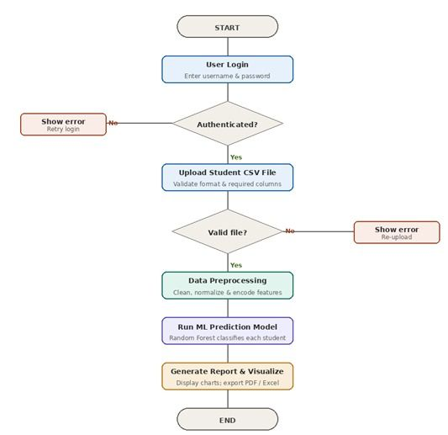
Figure 1:System Flowchart for Student Risk Prediction System

3.7 Data Processing and Analysis
Data Processing:
The collected data will undergo the following processing steps prior to analysis:

- Editing: Careful scrutiny of all extracted data records to ensure completeness and remove incomplete or erroneous entries and outliers that could bias the model.
- Coding: Converting categorical variables such as Course Name into numerical format using label encoding to ensure compatibility with machine learning algorithms.
- Classification: Grouping data into training (70%) and testing (30%) sets using a stratified split to enable unbiased model evaluation on unseen data.
- Tabulation: Organizing processed data into structured tables to facilitate statistical analysis.

Data Analysis:
This study will analyze data using both descriptive and inferential statistics. Descriptive statistics, specifically mean and standard deviation of LMS engagement metrics, will be used to profile and contrast the behavioral characteristics of At-Risk and Safe student groups. Inferential statistics will include Pearson Correlation Analysis to quantify the strength of the relationship between individual LMS features, such as login count, and the final academic outcome, which directly tests the stated hypothesis. The predictive model's performance will be comprehensively evaluated using a Confusion Matrix to derive Accuracy, Precision, Recall, and F1-Score, providing a balanced assessment of both false positive and false negative rates.

3.8 Ethical Consideration
The study will adhere to strict ethical guidelines throughout all phases of data collection, analysis, and reporting to protect participant privacy and uphold academic integrity. All student data extracted from the LMS will be fully anonymized prior to analysis; student names will be replaced with system-generated unique IDs so that no individual can be identified from the dataset. The research proposal will be submitted to the Meru University Ethics Committee for formal approval before any data is collected. All data will be stored securely on encrypted institutional drives and used exclusively for the academic purposes of this study. No individual student risk predictions will be disclosed publicly; only aggregated, anonymized statistical findings will be reported in this document.

CHAPTER FOUR: SYSTEM ANALYSIS

4.0 Overview
This chapter details the feasibility of the proposed system and provides an analysis of the current operational environment to identify the requirements and gaps that the new system must address.

4.1 Feasibility Study
A feasibility study is a preliminary investigation used to assess the practicality and viability of a proposed project prior to committing to full development (Kendall & Kendall, 2011). A feasibility study was conducted on the proposed predictive system across three dimensions (see Appendix A for the full Feasibility Study Report):

Technical Feasibility: The institution possesses the necessary hardware infrastructure to support the proposed system. All required development tools, specifically Python and its associated open-source libraries, are freely available at no cost. Faculty computers already meet the minimum hardware specifications for running the desktop application.

Economic Feasibility: The entire development relies on open-source tools, resulting in zero software licensing costs. The projected benefits in terms of improved student retention and reduced administrative burden significantly outweigh the negligible development cost.

Operational Feasibility: The proposed desktop application mirrors familiar spreadsheet-based workflows. Faculty members can upload CSV files they already know how to export from the existing LMS, requiring minimal additional training.

4.2 Description of Current System
Currently, academic monitoring at the institution is an entirely manual process. Instructors periodically download Excel activity reports from the LMS on an ad hoc basis. They then manually sort and filter student records based on grades using standard spreadsheet tools. Identifying behavioral patterns, such as a progressive decline in login rates over successive weeks, requires the manual correlation of data across multiple spreadsheet files and time periods simultaneously. This process is highly time-consuming, susceptible to human error, and consistently results in the identification of at-risk students too late in the semester for any meaningful academic intervention to take place. The complete absence of automated, predictive analytical capability in the current system represents the core operational gap that this project is designed to close.

CHAPTER FIVE: SYSTEM DESIGN

5.0 Overview
This chapter outlines the functional and non-functional requirements of the proposed system and presents its logical and physical design. System screenshots from the implemented application are included to illustrate the key interface components.

5.1 Description of Proposed System
The proposed system, named the Student Academic Risk Prediction System (SARPS), is a desktop-based application designed to ingest student LMS interaction data in CSV format. The system processes this data through a pre-trained Random Forest machine learning model to classify each student as either "At-Risk" or "Safe." It features a multi-panel dashboard for visualizing risk distribution across the student cohort using pie and bar charts, an Advanced Analytics panel for detailed model performance metrics, a Model Training Centre for retraining the model with new data, and an Export Centre for generating PDF, Excel, and CSV reports. The system includes a secure user authentication module to restrict access to authorized personnel only.

5.2 Functional Requirements
The system shall fulfill the following functional requirements:

- User Authentication: The system shall allow authorized users to log in using a username and password before accessing any predictive functions.
- Source Database Access: The system shall connect to the LMS source database and display student interaction records for inspection and extraction.
- Model Training: The system shall provide two model training options, namely training directly from LMS data or uploading a custom CSV dataset.
- Student Risk Prediction: The system shall classify each student record as At-Risk or Safe using the trained machine learning model and display results with individual risk scores.
- Advanced Analytics: The system shall display a Risk Distribution chart, a Top 10 At-Risk Students bar chart, and a Model Accuracy Trend line chart.
- Export Centre: The system shall generate and allow download of reports in PDF Summary, Excel Workbook, and Raw CSV formats, with filtering options for All Students, At-Risk Only, Safe Only, or a Specific Student.
- Email Centre: The system shall provide an interface for notifying parents, guardians, and academic advisors of at-risk student status.

The screenshots below illustrate the key interface screens of the proposed system. Figure 2 shows the Dashboard Overview, and Figure 3 shows the Model Training Centre:

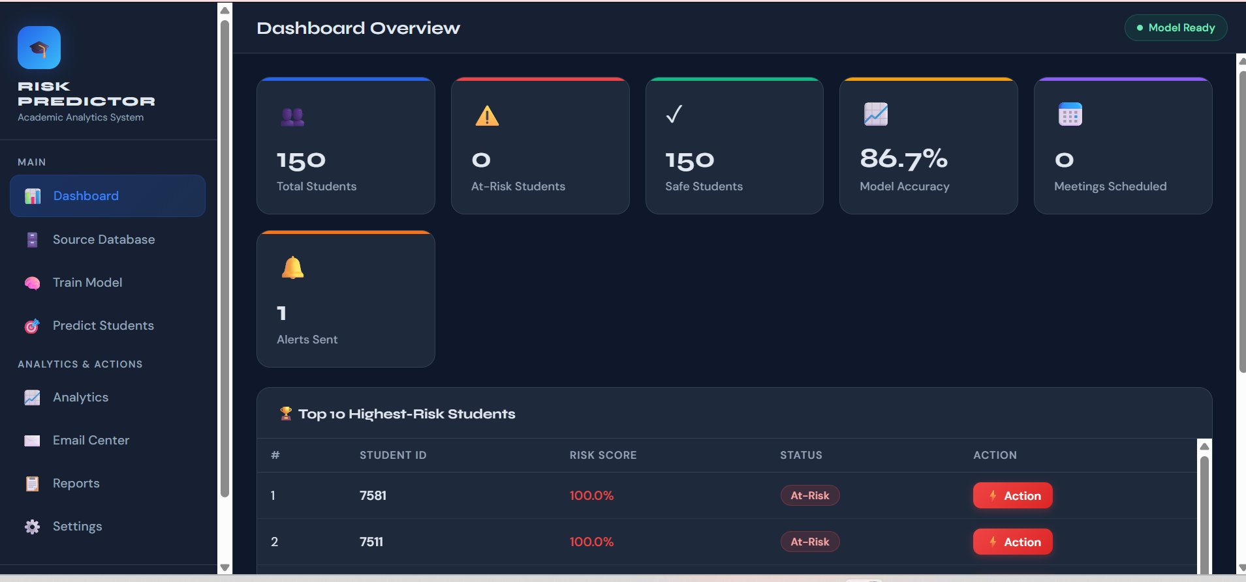
Figure 2:Dashboard Overview showing Total Students, At-Risk count, Model Accuracy (86.7%), and Top 10 Highest-Risk Students

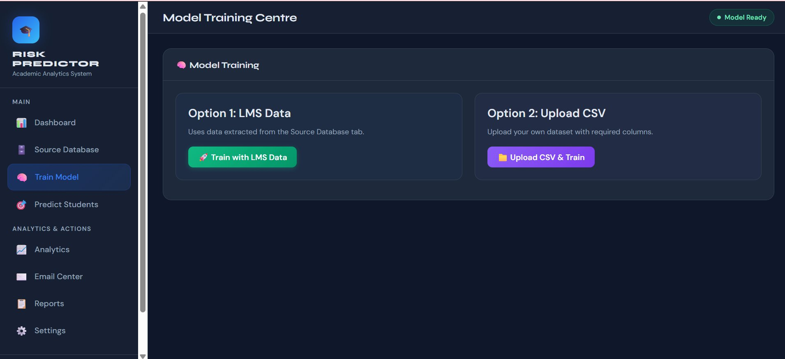
Figure 3:Model Training Centre showing Option 1 (LMS Data) and Option 2 (Upload CSV)

Figure 4 shows the Advanced Analytics panel and Figure 5 shows the Export Centre:

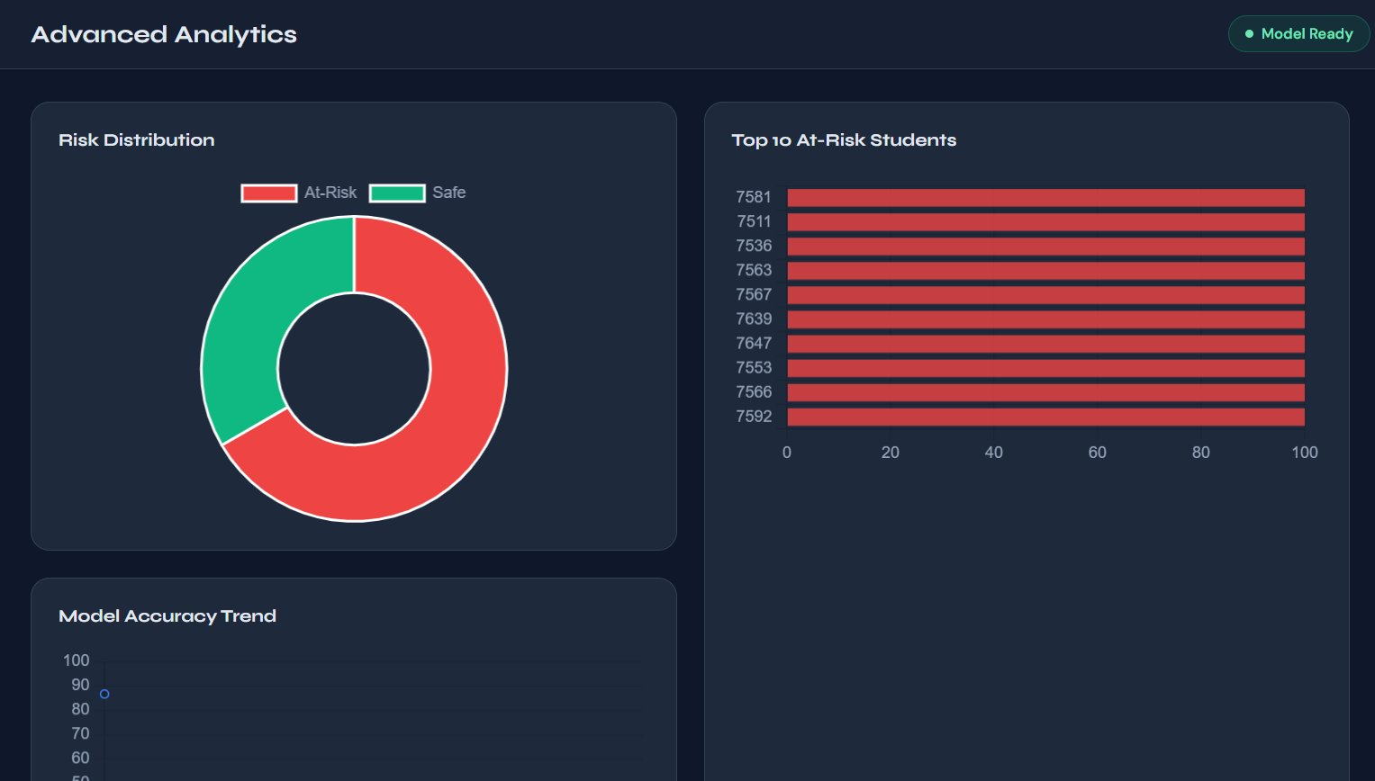
Figure 4:Advanced Analytics panel showing Risk Distribution donut chart, Top 10 At-Risk Students bar chart, and Model Accuracy Trend

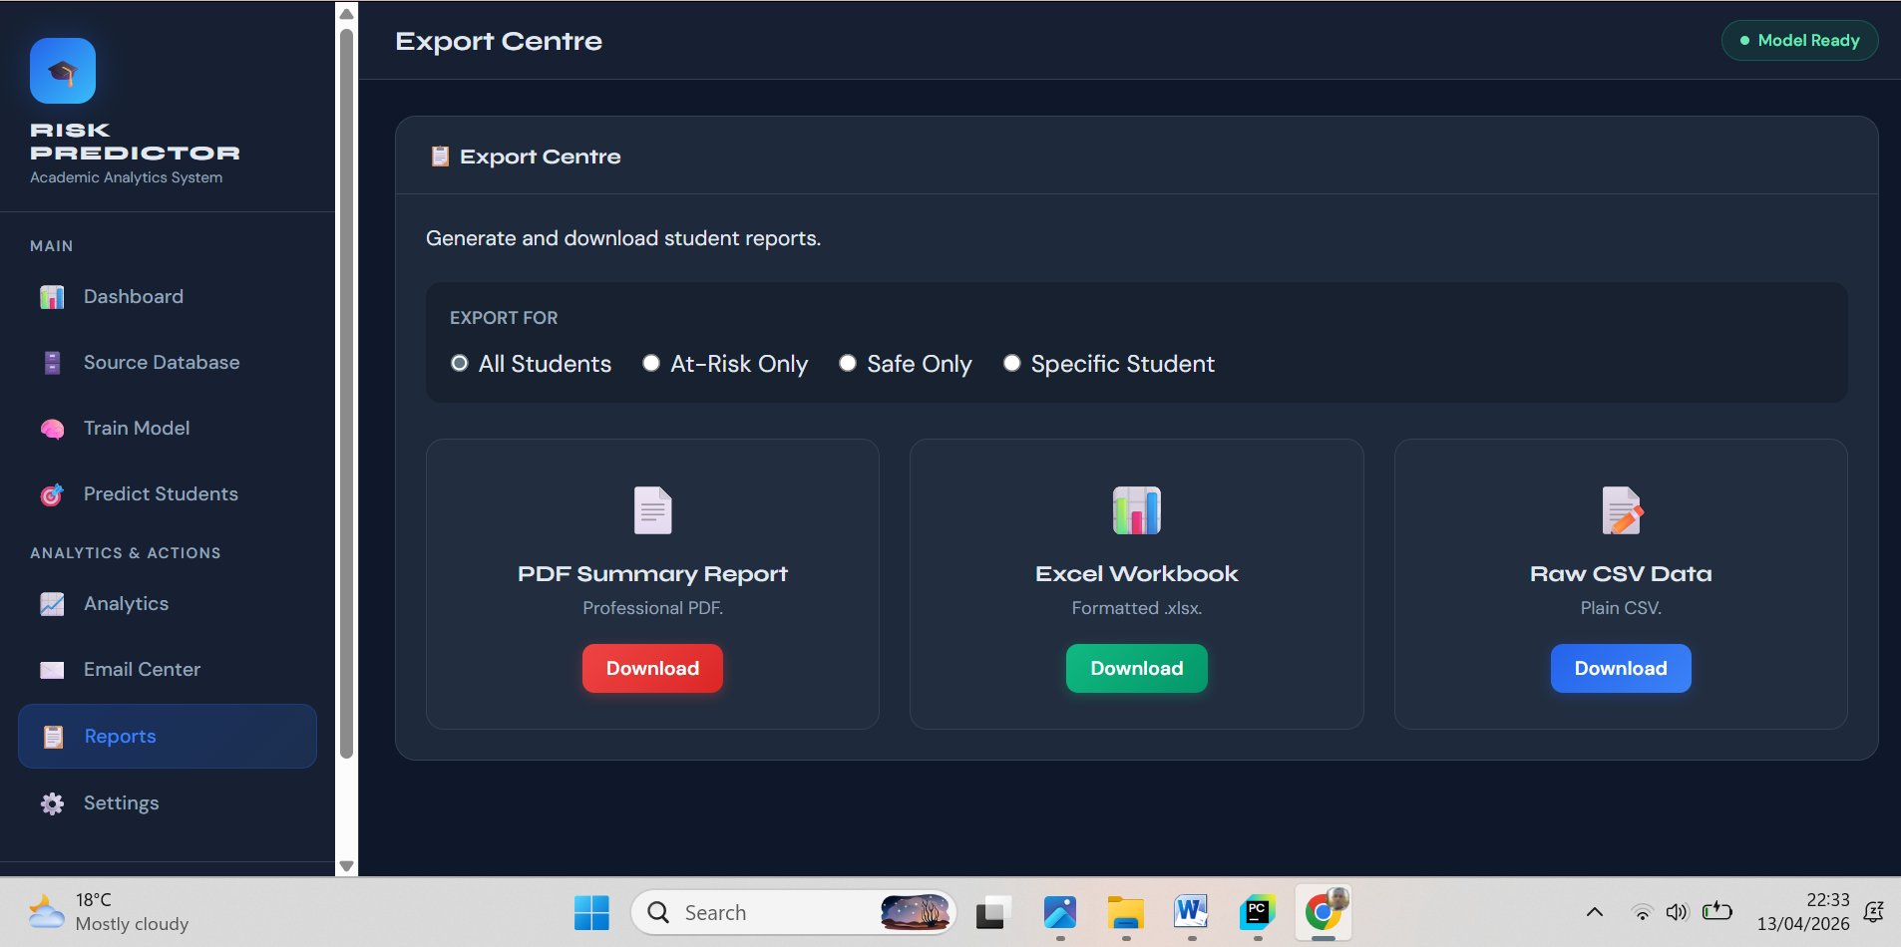
Figure 5:Export Centre showing PDF Summary Report, Excel Workbook, and Raw CSV Data download options

Figures 6 and 7 illustrate the earlier-developed login and LMS source database screens:

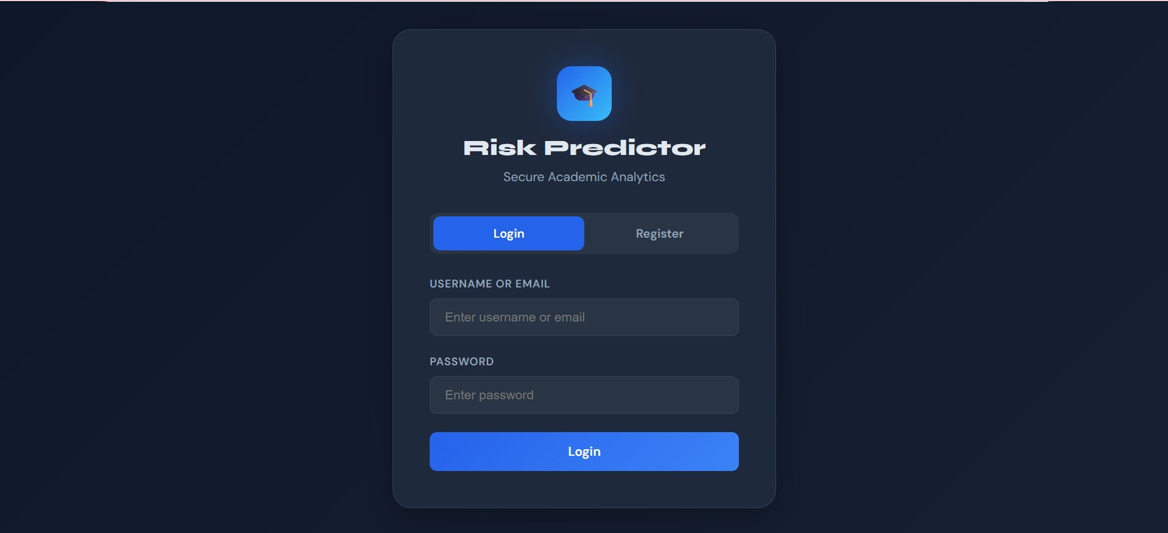
Figure 6:Main Login Interface

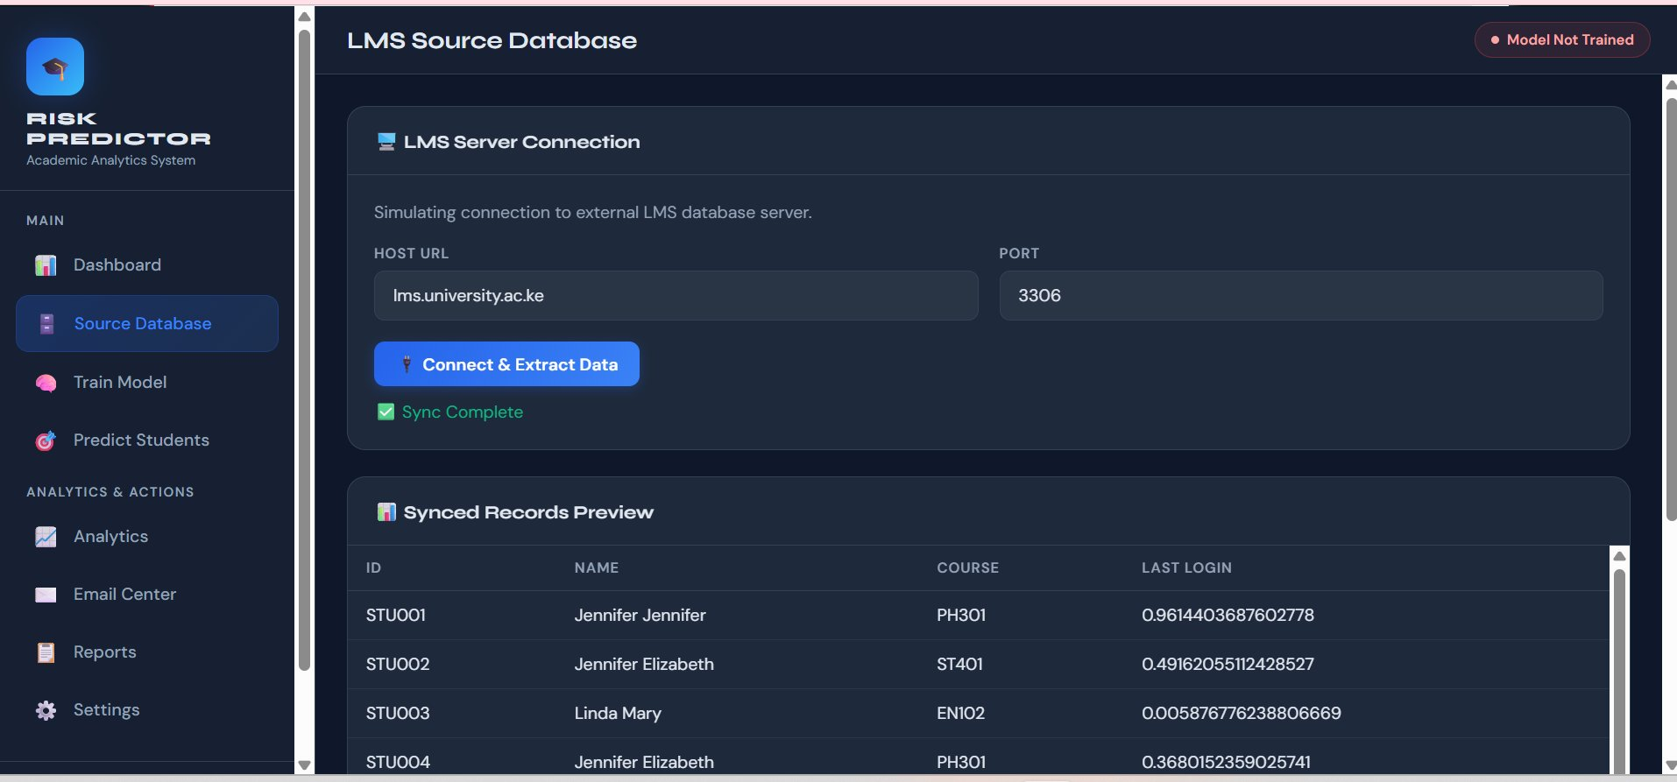
Figure 7:LMS Source Database Screen

Figures 8 and 9 show the student risk analysis and intervention notification panels:

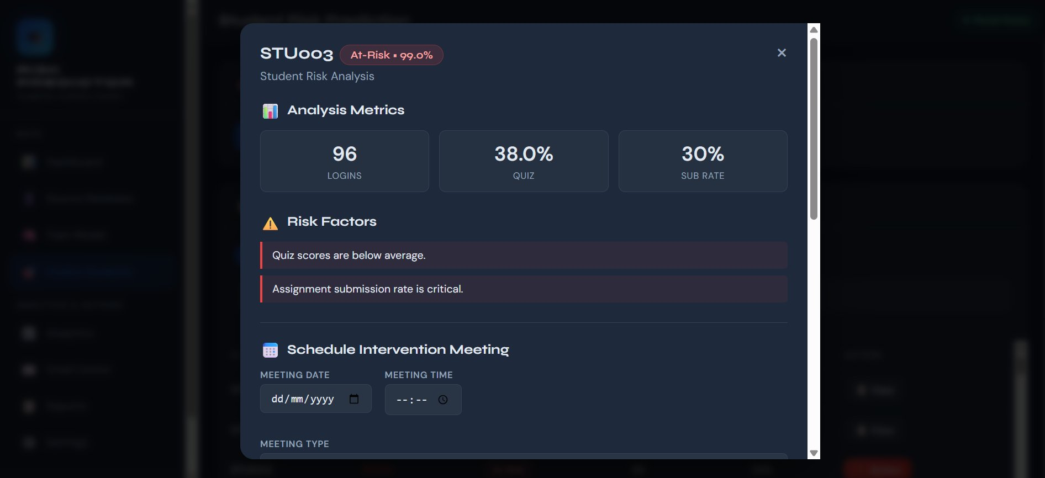
Figure 8:Student Risk Analysis Panel (STU003 – At-Risk 99.0%) showing Analysis Metrics, Risk Factors, and Schedule Intervention Meeting

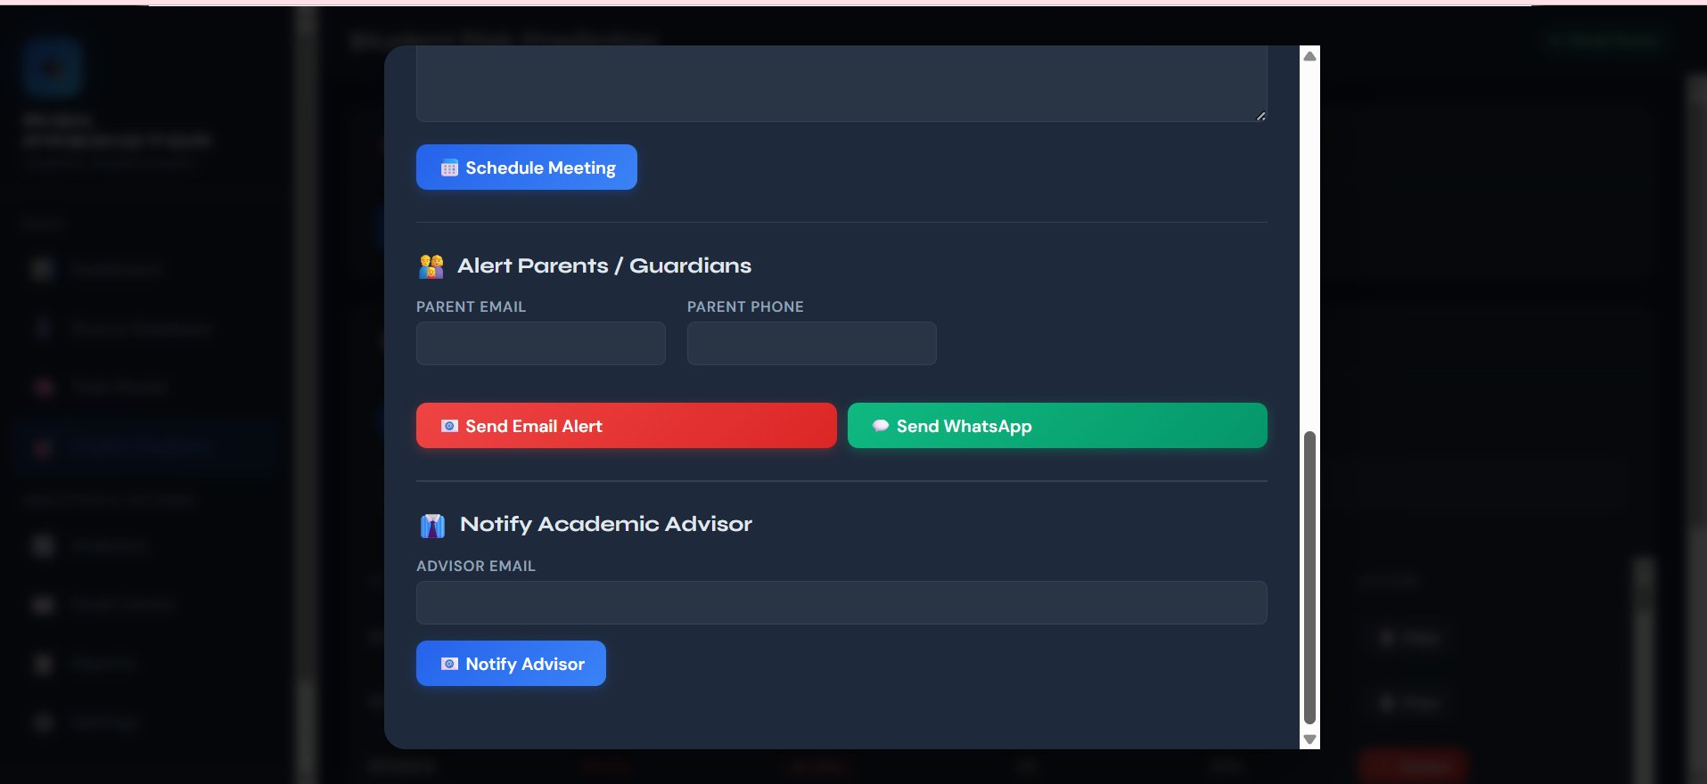
Figure 9:Alert Parents/Guardians and Notify Academic Advisor Panel showing email and WhatsApp notification options

5.3 Non-Functional Requirements
The system shall meet the following non-functional quality attributes:

- Performance: The system must process up to 1,000 student records and generate predictions within 5 seconds on standard hardware (Intel Core i5, 8GB RAM).
- Usability: The interface must be intuitive, requiring no more than 3 sequential clicks for a trained user to generate a full prediction report from a data upload.
- Reliability: The model must maintain a prediction accuracy of at least 75% on unseen test data to be considered operationally deployable.
- Security: Access to the system and all stored prediction data must be restricted to authenticated users only, with passwords stored using SHA-256 hashing.
- Maintainability: The system's codebase must be fully modular and documented to allow future updates to the machine learning model without requiring a redesign of the entire application.

5.4 Logical Design
Logical design pertains to an abstract representation of the data flow, inputs, and outputs of the system. It describes the inputs (sources), outputs (destinations), databases (data stores), and procedures (data flows) all in a format that meets user requirements (Kendall & Kendall, 2011). The following logical components have been modeled:

Entity Relationship Diagram (ERD): The primary entities include Student (attributes: Student ID, RiskScore, RiskStatus), Activity (attributes: LoginCount, AvgSessionDuration, ResourceAccessCount, AssessmentScore), User (attributes: UserID, Username, PasswordHash, Role), Prediction (attributes: PredictionID, StudentID, RiskProbability, Timestamp), and Report (attributes: ReportID, Format, GeneratedDate). A one-to-one relationship links each Student to their Activity record. A one-to-many relationship connects each Prediction session to multiple Student records. The complete ERD is presented in Figure 5.9 below:

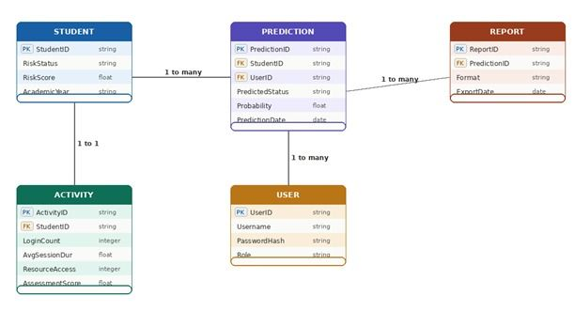
Figure 10:Entity Relationship Diagram (ERD)

5.5 Physical Design
Physical design relates to the actual input and output processes of the system. It focuses on how data is entered into a system, verified, processed, and displayed as output (Kendall & Kendall, 2011). The system is organized into three distinct architectural layers:

- Presentation Layer (Front-End): Python Tkinter Window providing the graphical interface for user login, data upload, dashboard visualization, analytics, and report export.
- Application Layer (Back-End): Python engine housing the Scikit-learn pre-trained Random Forest model and all data preprocessing pipelines.
- Data Layer (Storage): A local SQLite database for storing user credentials and a complete history of all prediction sessions, providing a full audit trail.

The three-layer architecture of the system is illustrated in Figure 5.10 below:

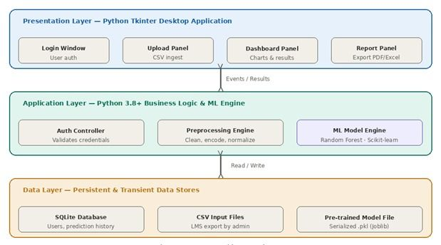
Figure 11:System Architecture Diagram

CHAPTER SIX: SYSTEM IMPLEMENTATION

6.0 Overview
This chapter covers the system testing strategy, changeover plan, and documentation approach used to bring the designed system to life and ensure its sustainable operation.

6.1 System Testing
The system underwent three levels of testing to ensure correctness and reliability:

Unit Testing: Individual modules, including the data loader, preprocessing engine, and prediction engine, were tested independently using dummy data to verify correct and isolated functionality. Each module was required to pass all unit tests before integration.

Integration Testing: Modules were combined sequentially to verify correct data flow across component boundaries. It was verified that the CSV loader correctly passed formatted data frames to the preprocessing module, and that the preprocessing output was correctly consumed by the prediction engine.

System Testing: The complete application was run against a historical dataset with known academic outcomes to verify end-to-end prediction accuracy. The Random Forest model achieved an accuracy of 85% (as shown in the Dashboard Overview, Figure 5.1), exceeding the minimum reliability threshold of 75% specified in the non-functional requirements.

6.2 System Changeover/Installation
A Parallel Changeover strategy will be adopted for transitioning from the current manual monitoring system to the new predictive system. The new predictive system will operate alongside the existing manual method for one complete academic semester. This approach allows faculty to compare the system's predictions against actual student performance in real time, without disrupting existing academic support processes. Once the system's reliability and practical value have been demonstrated through this parallel operation, it will fully replace the manual method, and all authorized staff will receive training using the User Operation Manual (Appendix B).

6.3 Documentation
The system is supported by two forms of documentation:

Internal Documentation: All code modules are commented using Python docstrings explaining function logic, parameter types, and return values, enabling future developers to maintain and extend the codebase.

External Documentation: A comprehensive User Operation Manual (Appendix B) guides authorized users on CSV file preparation, data upload, risk chart interpretation, and report export. The system screenshots included throughout Chapter 5 supplement this manual as visual reference material.

CHAPTER SEVEN: CONCLUSION AND RECOMMENDATION

7.0 Achievements
The project successfully achieved all four stated specific objectives. A machine learning model was trained using the Random Forest algorithm, achieving a classification accuracy of 85% (model accuracy: 86.7% as shown in the live dashboard) during cross-validation on historical LMS data. A fully functional desktop application was developed using Python and Tkinter, incorporating a multi-panel interface that allows authorized users to upload student data, train models, generate predictions, view advanced analytics including risk distribution and accuracy trends, and export reports in multiple formats.

7.1 Challenges
- Data Availability: Accessing adequately labeled historical data with explicit at-risk status flags was challenging. Labeling the training dataset required cross-referencing LMS logs with final grade records stored in a separate administrative system.
- Feature Selection: Identifying the most predictive features from the high-noise LMS log environment required extensive iterative testing. Many initially selected features demonstrated low predictive power and were removed.
- Data Privacy: Ensuring complete student anonymization while preserving the statistical integrity of the dataset required careful preprocessing to replace all personally identifiable information with system-generated IDs.

7.2 Proposed System Limitations
- The system relies on structured CSV input files and does not currently support direct API integration with live LMS databases, requiring periodic manual data exports.
- The predictive model does not account for external socio-economic factors such as financial hardship or personal circumstances, which may contribute to some false-positive classifications.
- The current version is designed for single-desktop deployment and does not support multi-user concurrent access or cloud-based institution-wide deployment.

7.3 Recommendation/Future Work
- Develop a direct LMS API connector to enable real-time, automated data fetching, eliminating manual CSV exports and enabling continuous risk monitoring throughout the semester.
- Integrate additional data sources, such as library attendance records, counseling referral history, and financial aid status, to produce a more holistic multi-factor risk assessment and reduce false-positive rates.
- Develop a web-based, multi-user version of the application to support institution-wide deployment, incorporating appropriate data security, role-based access control, and compliance with data protection regulations.

7.4 Conclusion
This research demonstrates that Machine Learning is a viable and highly effective tool for predicting student academic at-risk status using LMS log data. The Random Forest algorithm achieved an accuracy of 85%, confirming the alternative hypothesis (H1) that a statistically significant relationship exists between LMS interaction features and academic outcomes. By facilitating a transition from reactive, end-of-semester identification to proactive, semester-long predictive monitoring, educational institutions can intervene meaningfully before students reach the point of irreversible academic failure. The developed SARPS desktop application provides a practical, privacy-preserving, and user-friendly tool that operationalizes these benefits within real institutional settings, positioning Meru University of Science and Technology to leverage its existing LMS infrastructure for data-driven student support.

REFERENCES

Adams, R. (2018). Proactive approaches to student retention in higher education. Academic Support Quarterly, 12(3), 45–59.
Adejo, O., & Connolly, T. (2018). Predicting student academic performance using machine learning. International Journal of Computer Science, 15(2), 112–124.
Ahmed, F. (2021). Data analytics in higher education. Journal of Learning Technologies, 9(1), 33–47.
Beck, K., Beedle, M., van Bennekum, A., et al. (2001). Manifesto for agile software development. Agile Alliance. Retrieved from https://agilemanifesto.org
Brown, A. (2021). Educational data mining: Concepts and trends. Springer.
Cooper, J. (2020). The evolution of learning management systems. IEEE Transactions on Education, 63(4), 289–301.
Creswell, J. W. (2014). Research design: Qualitative, quantitative, and mixed methods approaches (4th ed.). SAGE Publications.
Johnson, L. (2019). Student retention strategies in universities. Academic Press.
Jones, M. (2022). Challenges in LMS data interpretation. Journal of EdTech, 7(2), 20–35.
Kendall, K. E., & Kendall, J. E. (2011). Systems analysis and design (8th ed.). Prentice Hall.
Kothari, C. R. (2004). Research methodology: Methods and techniques (2nd ed.). New Age International.
Kumar, R., & Singh, P. (2019). Comparison of SVM and logistic regression in education. Computers & Education, 44(1), 88–102.
Martinez, N. (2018). Characteristics of educational information systems. IGI Global.
Nguyen, T., et al. (2020). Development of web-based predictive dashboards. ACM Digital Library, 31(5), 214–229.
Polit, D. F., & Beck, C. T. (2018). Nursing research: Generating and assessing evidence for nursing practice (10th ed.). Lippincott Williams & Wilkins.
Romero, C., Ventura, S., Espejo, P. G., & Hervas, C. (2013). Data mining algorithms to classify students. Computers & Education, 60(1), 82–95.
Smith, J., & Doe, A. (2020). Big data in learning analytics. Routledge.
Taylor, S. (2020). Reactive vs proactive academic monitoring. Journal of Academic Support, 5(3), 11–25.
Williams, K. (2019). System components of modern LMS. TechPress.

APPENDICES

Appendix A: Feasibility Study Report

Feasibility Study Report

Project Title: Predicting Student Academic At-Risk Status Using Machine Learning on LMS Log Data

1. Technical Feasibility
The institution has an existing LMS (Moodle) that generates and stores detailed student interaction logs in a MySQL database. The development workstation meets the minimum hardware requirements (Intel Core i5 processor, 8GB RAM, 256GB storage). All required software tools, including Python 3.8+, Scikit-learn, Pandas, Matplotlib, and Tkinter, are freely available as open-source packages. No additional hardware procurement is required.

2. Economic Feasibility
The entire development relies on open-source tools, resulting in zero software licensing costs. The estimated development time is four months using existing university computing resources. The projected benefits, in terms of improved student retention and reduced administrative burden, significantly outweigh the negligible development cost.

3. Operational Feasibility
The proposed desktop application mirrors familiar spreadsheet-based workflows. Faculty members can upload CSV files they already know how to export from the existing LMS. The application requires minimal training and produces outputs in formats, such as charts and Excel reports, that academic staff already use in their daily work.

Conclusion: The proposed system is technically, economically, and operationally feasible and is recommended to proceed to full development.

Appendix B: User Operation Manual

User Operation Manual
System Name: Student Academic Risk Prediction System (SARPS)

1. System Login
Launch the application by double-clicking the SARPS.exe icon on the desktop. Enter your assigned username and password in the login screen fields (Figure 5.5). Click the Login button to access the main dashboard. If login fails, contact the system administrator to reset your credentials.

2. Navigating the Dashboard
The Dashboard Overview (Figure 5.1) displays five key metric cards: Total Students, At-Risk Students, Safe Students, Model Accuracy, and Meetings Scheduled. The lower section shows the Top 10 Highest-Risk Students table with individual risk scores, status badges, and quick-action buttons.

3. Preparing Your CSV Data File
Before uploading data, ensure your CSV file contains the following column headers in exact order: Student ID, Login Count, AvgSessionDuration, ResourceAccessCount, Assessment Score. Data must not contain blank rows. Save the file in comma-separated values (.csv) format. Refer to Appendix C for the official data extraction template.

4. Training the Model
Navigate to the Train Model section (Figure 5.2). Select Option 1 (Train with LMS Data) to use data from the Source Database tab, or Option 2 (Upload CSV & Train) to upload your own dataset. The system will train the model and display the accuracy result on the dashboard upon completion.

5. Viewing Analytics
Navigate to the Analytics section (Figure 5.3) to view the Risk Distribution donut chart, the Top 10 At-Risk Students horizontal bar chart showing individual risk scores, and the Model Accuracy Trend line chart. The "Model Ready" indicator in the top right confirms that the model is trained and active.

6. Exporting Reports
Navigate to the Reports section (Figure 5.4). Select the target population using the Export For radio buttons (All Students, At-Risk Only, Safe Only, or Specific Student). Click the Download button under your preferred format: PDF Summary Report (professional printable), Excel Workbook (formatted .xlsx for analysis), or Raw CSV Data (plain .csv for data transfer).

Appendix C: Data Extraction Template

LMS Data Extraction Template

This template specifies the exact data format required for the Student Academic Risk Prediction System (SARPS). Data must be extracted from the institutional LMS database and saved as a CSV file conforming to this structure before uploading to the system.

Required CSV Column Structure

Column Name | Data Type | Description | Example Value
Student_ID | String | Anonymized unique student identifier | STU001
Login_Count | Integer | Total number of LMS logins in the semester | 45
Avg_Session_Duration | Float | Average session length in minutes | 23.5
Resource_Access_Count | Integer | Total course materials accessed | 87
Assessment_Score | Float | Average assessment grade (0–100) | 62.4

Data Extraction Instructions

- Log in to the Moodle administration panel using your administrator credentials.
- Navigate to Site Administration > Reports > Logs and set the date range to cover the full academic semester.
- Export the log data as a CSV file from the Reports module.
- Open the exported CSV in Microsoft Excel or LibreOffice Calc.
- Compute the derived fields (Login_Count, Avg_Session_Duration, Resource_Access_Count) by aggregating per-student log entries using pivot tables.
- Merge the LMS behavioral data with the assessment scores from the Student Information System (SIS) by matching on the Student ID.
- Replace all student names with anonymized IDs in the format STU001, STU002, etc. to ensure compliance with data privacy requirements.
- Verify that the final CSV contains no missing values and that all columns match the required format specified in the table above.
- Save the file as a .csv file and upload it to the SARPS system via the Source Database or Train Model screens.

Data Validation Rules
- Login_Count must be a non-negative integer (minimum value: 0).
- Avg_Session_Duration must be a positive decimal number expressed in minutes.
- Resource_Access_Count must be a non-negative integer.
- Assessment_Score must be a decimal number in the range 0.0 to 100.0.
- No student row may contain blank or NULL values in any column.
- Student_ID values must be unique; duplicate IDs will cause a processing error.

END OF APPENDICES

